Smooth Streaming Player - ReadMe
SmoothStreamingPlayer.XAP is a prepackaged player that can easily be embedded in your own site to playback Smooth Streaming and Progressive Download media.

Embedding in a web page
To embed the Smooth Streaming Player simply add the following snippet of HTML to your page. Note: you will need to update the mediaurl parameter to point at your media as well as the width and height attributes to achieve a presentation size that fits your site design.
<object data="data:application/x-silverlight-2," type="application/x-silverlight-2" width="100%" height="100%" >
<param name="source" value="SmoothStreamingPlayer.xap" />
<param name="minRuntimeVersion" value="4.0.50401.0" />
<param name="autoUpgrade" value="true" />
<param name="InitParams" value=" mediaurl=http://streams.smooth.vertigo.com/elephantsdream/Elephants_Dream_1024-h264-st-aac.ism/manifest" />
</object>

Next, make sure the SmoothStreamingPlayer.XAP file is located in the same hosting directory as the HTML file.
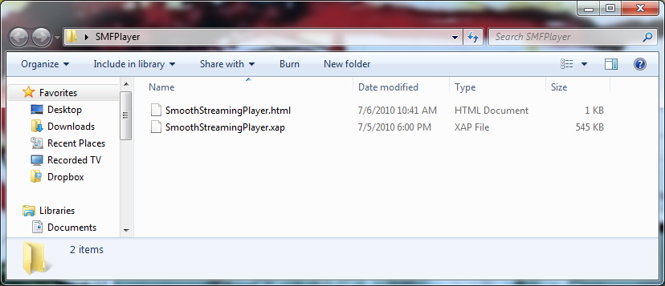

Configuration
The behavior of the Smooth Streaming Player can be configured by setting properties in the InitParams <param/> tag.

<object data="data:application/x-silverlight-2," height="100%" type="application/x-silverlight-2" width="100%">
<param name="source" value="SmoothStreamingPlayer.xap" />
<param name="minRuntimeVersion" value="4.0.50401.0" />
<param name="autoUpgrade" value="true" />
<param name="InitParams" value="selectedcaptionstream=textstream_eng,
mediaurl=http://streams.smooth.vertigo.com/elephantsdream/Elephants_Dream_1024-h264-st-aac.ism/manifest" />
</object>

The following properties are supported (case insensitive):
- MediaUrl – Specifies the location of the media to be played. This parameter is the only one that is required and is all that is needed to begin media playback.
- DeliveryMethod – This determines the type of plugin to use to play the media. The default value is Adaptive (Smooth Streaming).
  - Supported values: “Adaptive”& “Progressive Download”
- AutoPlay – Determines whether the media will begin playing automatically without waiting for the user to click Play. The default value is true.
- ThumbnailUrl – The url to an image that should be displayed to the user while waiting for them to click Play. This is only visible when AutoPlay = false.
- ScriptableName – The name used to refer to the Player object via client-side script (i.e. JavaScript).
- SelectedCaptionStream – The name of an adaptive text stream that carries DFXP formatted caption data. This option is only available when the DeliveryMethod is set to Adaptive.
- PluginUrl – Specifies the location of a plugin .XAP to be downloaded by the Player.

